Step 1 -registering using a username and email address (an email will be sent to this email address with a randomly generated, unique password to log in):

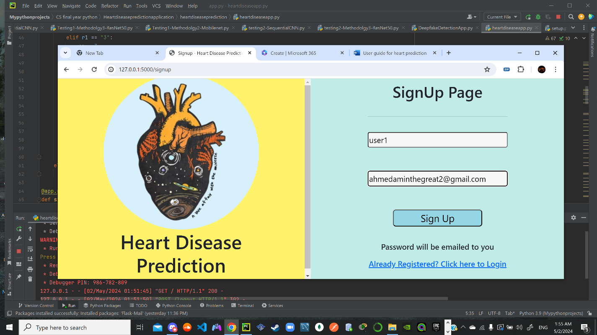

Step 2 - Logging into the website with the username and the password that was sent to the email (the username and password are stored in an SQLite database):

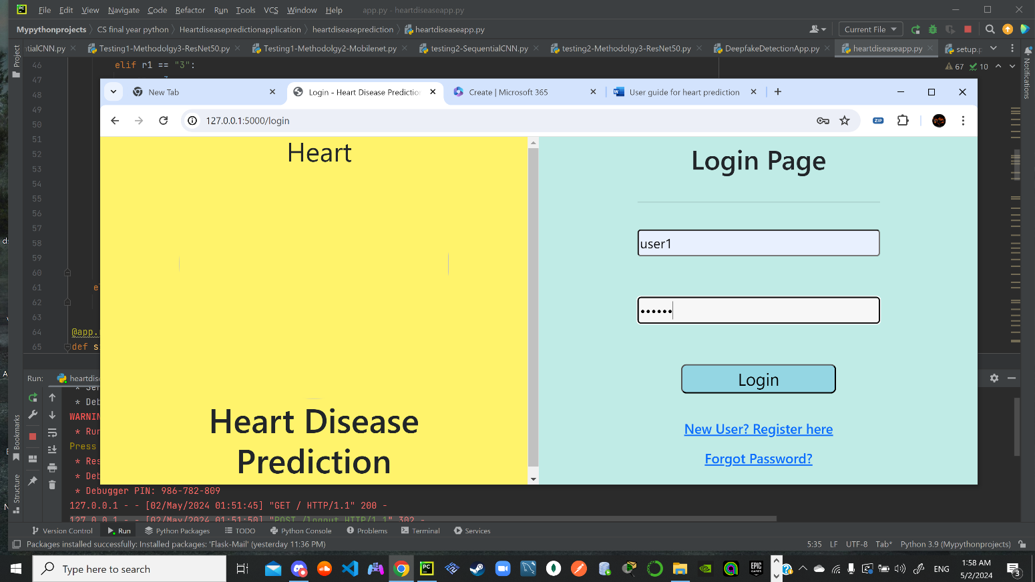

Step 3 – The view the user is greeted with when logged into the website:

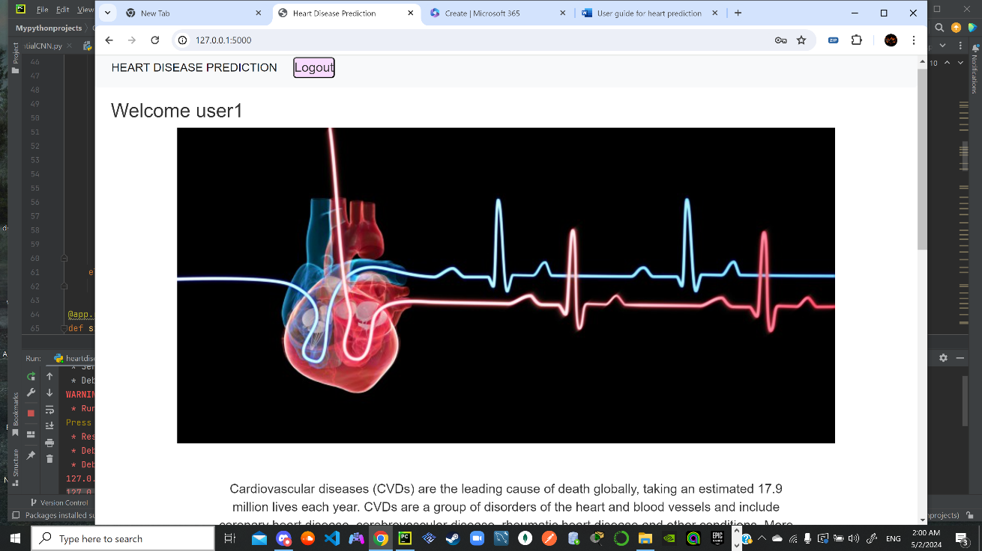

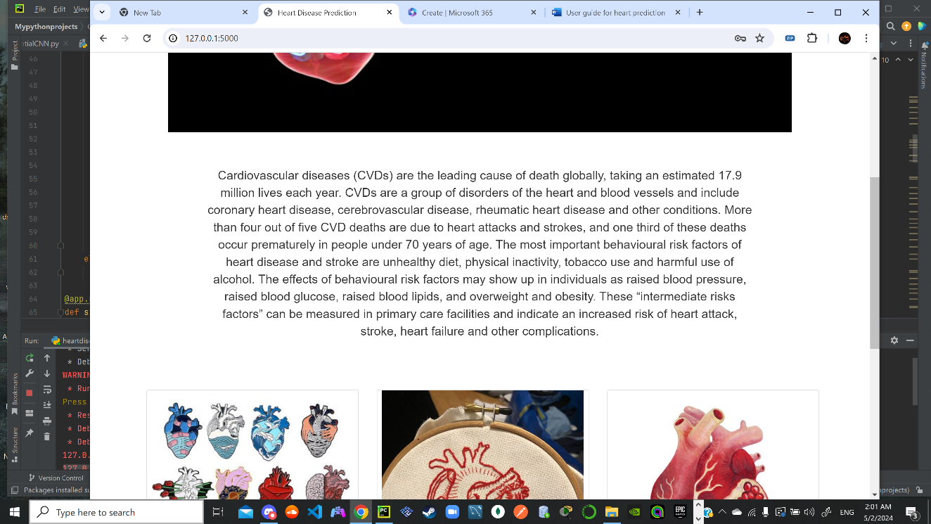

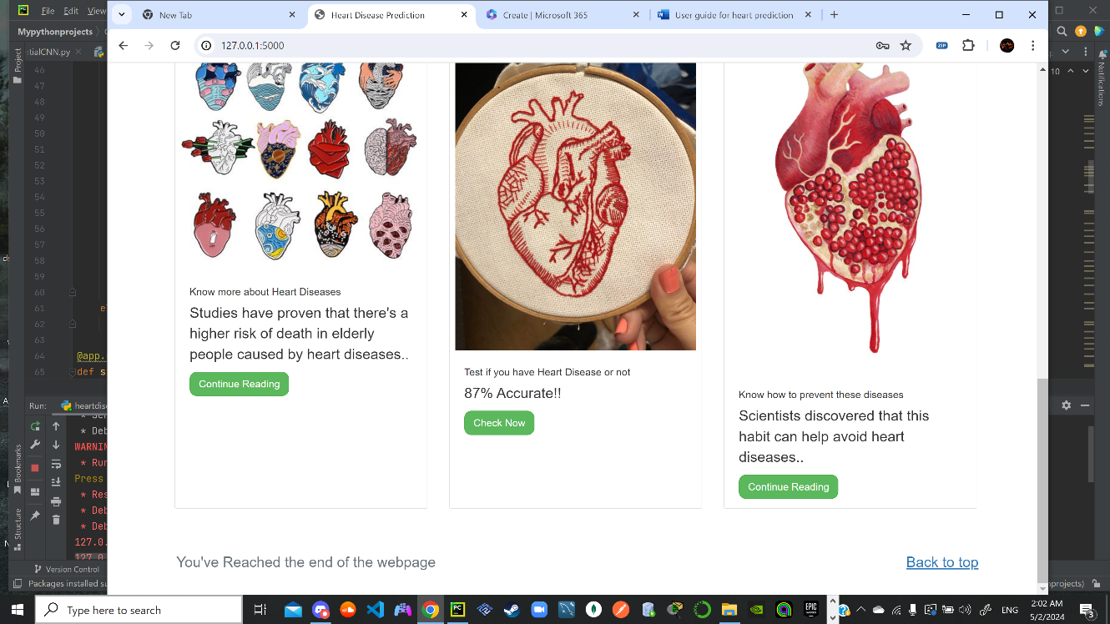

Step 4 – pressing on Continue reading to know more about heart diseases takes you to:

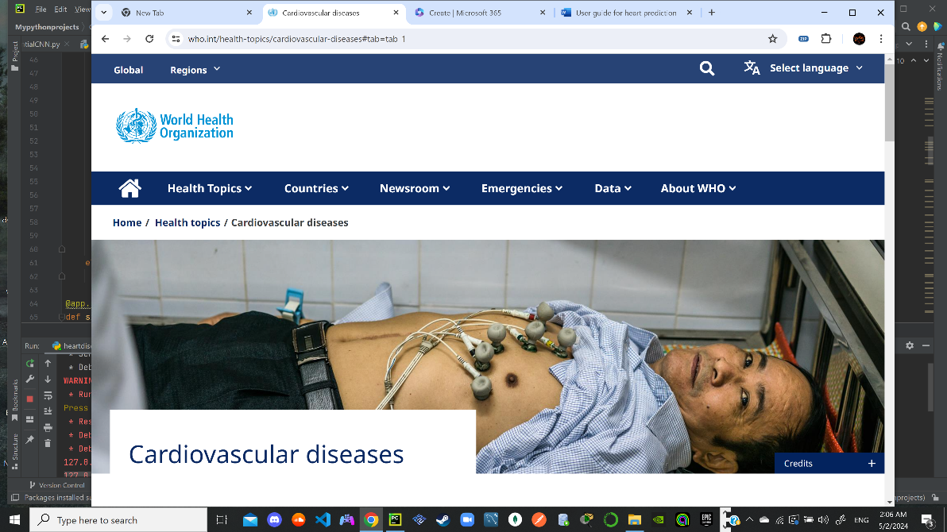

Step 5 – Pressing on continue reading to know how to prevent these diseases takes you to:

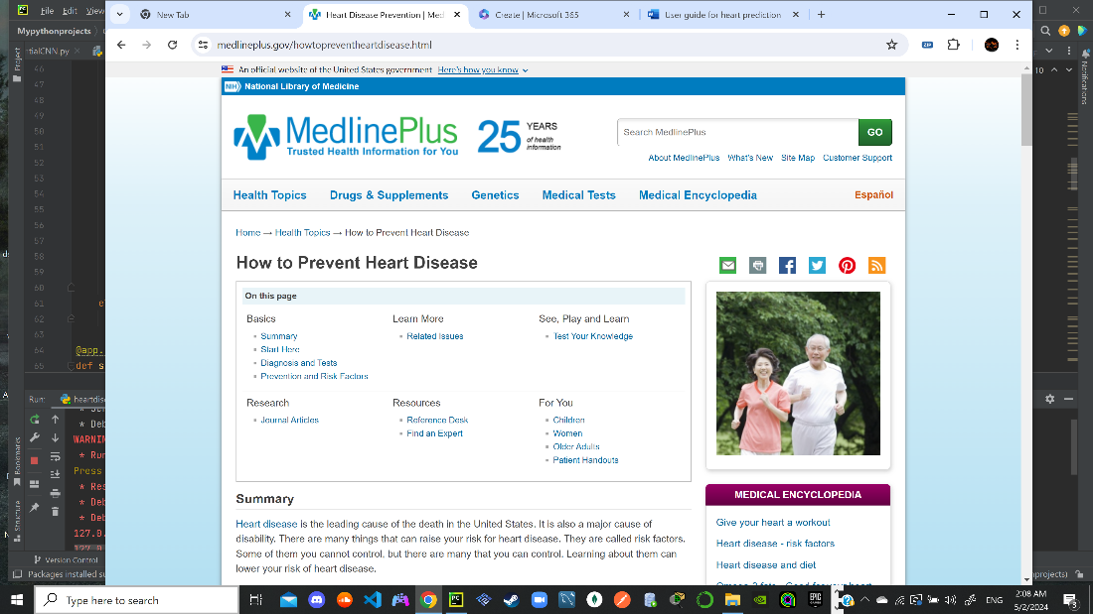

Step 6 – after pressing check now to test if you have a heart disease or not:

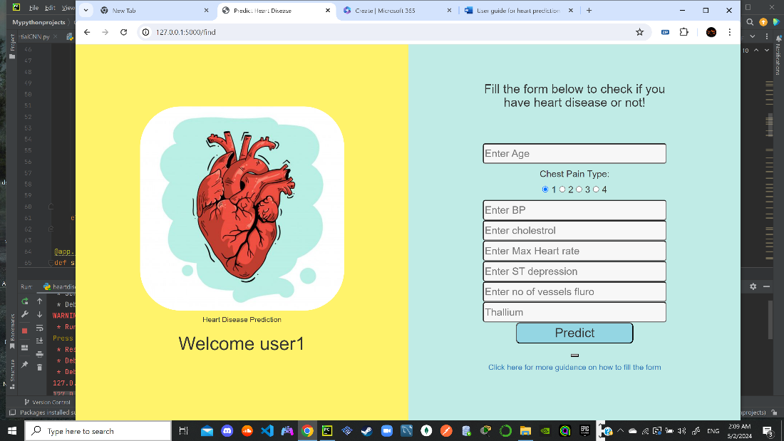

Step 7- Example of a user that has heart disease (prediction = “presence”):

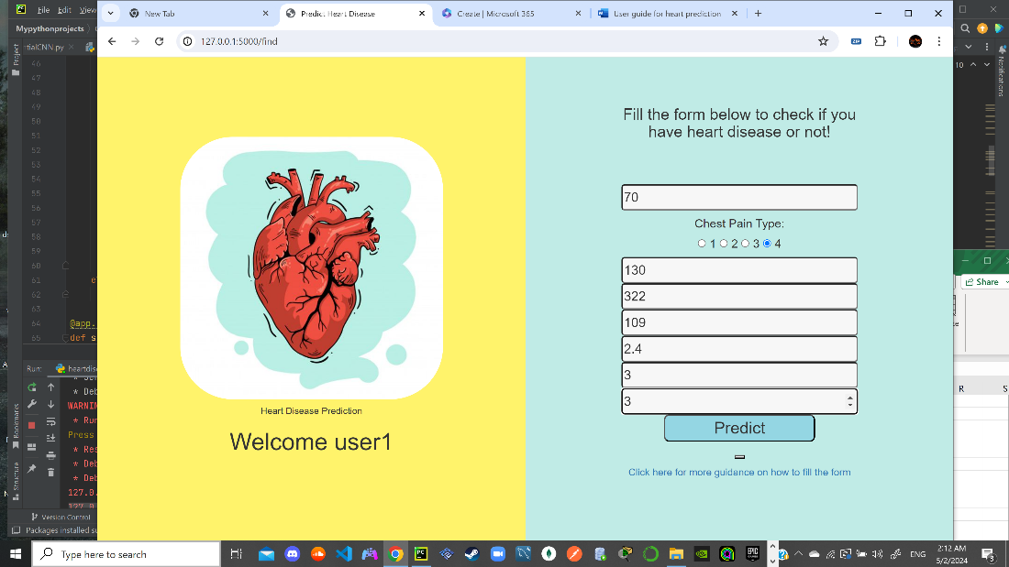

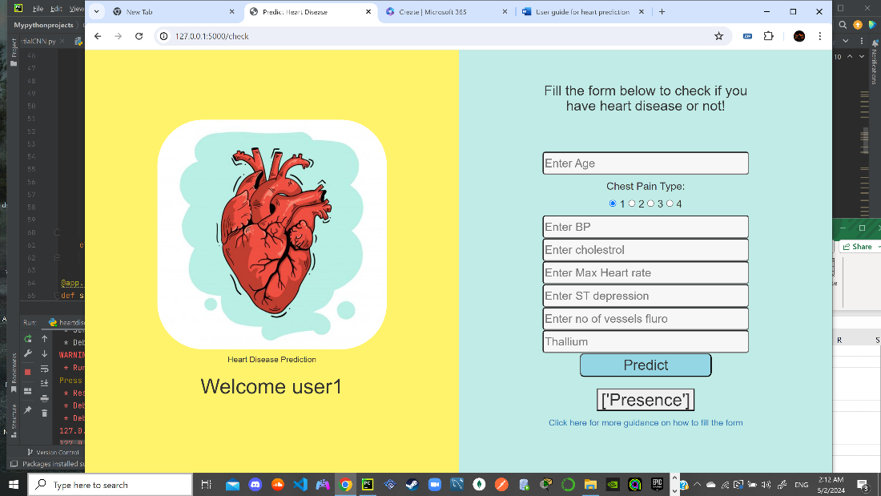

Step 8- Example of a user that doesn’t have heart disease (prediction = “absence”):

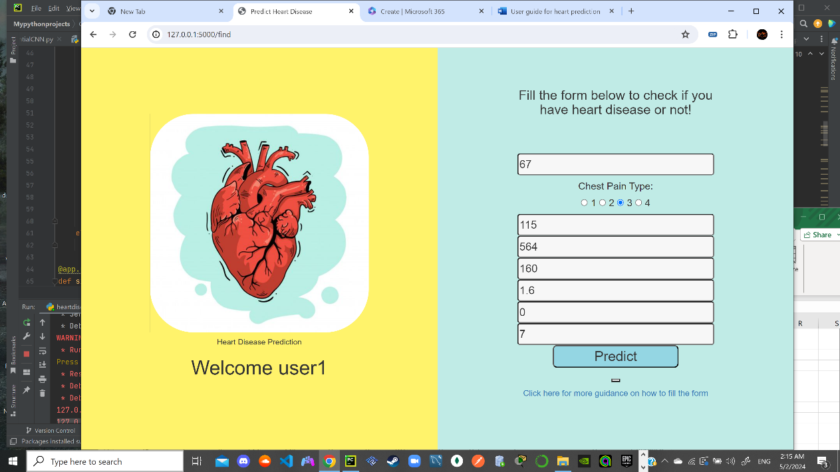

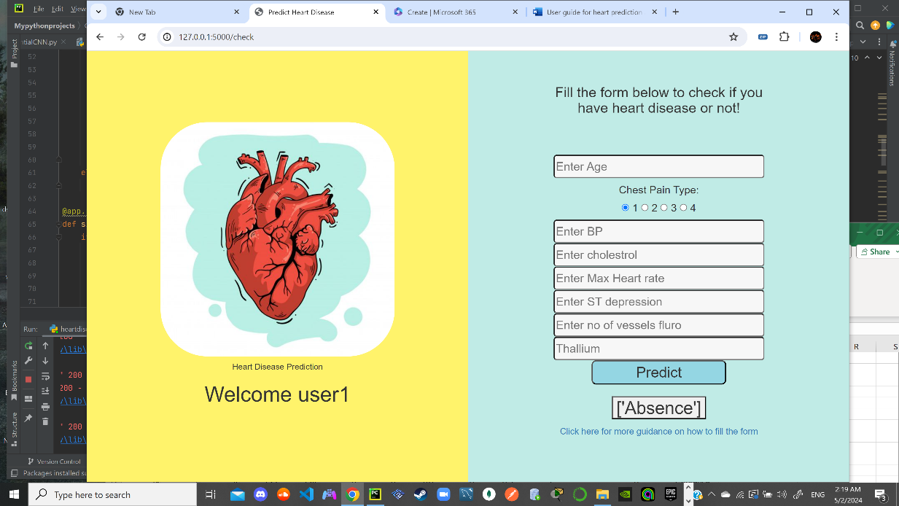

Step whenever – what to do if you forgot your password (new password will be sent to the email entered):

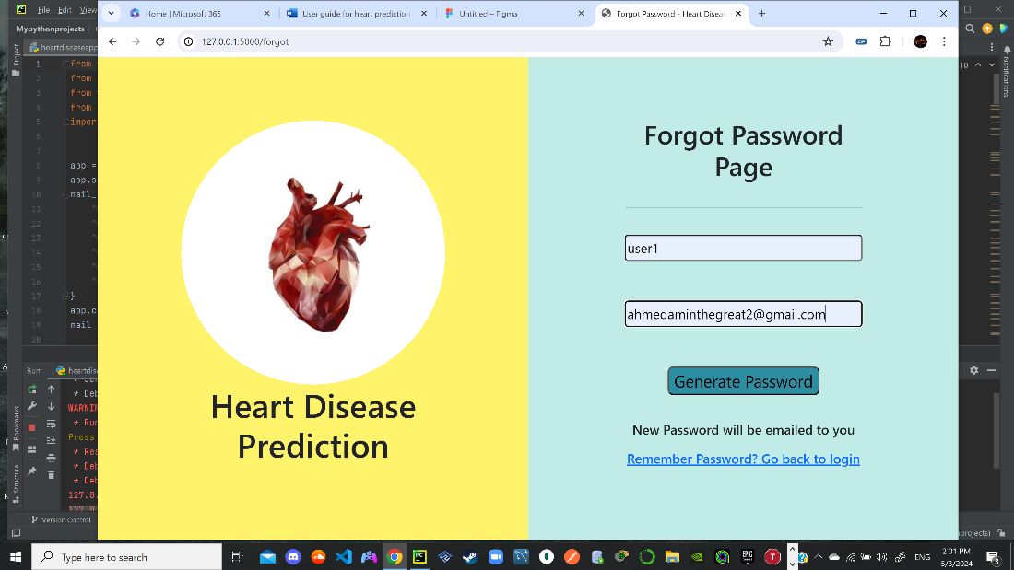

Full workflow:

